CIS-11 Project Documentation

Xbox Controllers
Ashley Gallegos
Ernesto Zarate
CIS11 Test Scores
June 11, 2026

Advisor: Kasey Nguyen, PhD

Part I – Application Overview

For the project that we will be working on, we will be considering the factors of multiple test scores from students in order to obtain the minimum, maximum, and average test scores. The purpose of this project is to demonstrate how we can arrive at certain measured test scores which could be implemented across different scopes of work, data, and everyday life. In a business aspect, let's say the entertainment industry, if we want to take in the data of a production company that produces multiple films at a time in a year, we can use data such as reviews, box office revenue, or salary discussions, to determine an average, maximum, and minimum. Depending on what specifics they want to analyze, we can use this project as a starting point to conduct entertainment business. As for software systems, we are consistently using tons and tons of data simply to use the internet, phones, or send messages. We can implement this project within that software system to look at different speeds of data, how that data is being used, and look at different intervals of when data spikes or falls.

Objectives

The objectives of this program are pretty simple and straightforward. Receive input data from a user, be it a teacher, data analyst, etc. the information we receive is inputted into our program and when compile is done, we get the information of a min, max, and avg. Upon getting this information of min, max, and avg we are able to apply this data logistically in order to examine the results and proceed to make changes that can either help the analyzed data, improve the analyzed data, or maintain a stable environment within the system that produced the data.

Why are we doing this?

While we aim to make the analysis of data more useful to the efficiency of a business, we must point out the specifics of how it truly will start to make a difference and impact on said business. For this, we are using the example of the entertainment industry to apply the program we are creating in order to showcase its many uses.
- For starters, one of the uses a production company could use the calculation of min, max, and avg. is to determine which types of genres rack in the most revenue, which don't, and which stay at a stable revenue stream. We can also determine which artist (actor/actress) is ‘hot’ meaning, which artist brings in the most cost efficient revenue for everyone all around. And lastly, a big question I think every production company should ask themselves is, “Should we keep making this movie title?” because in today's day and age, reboots and sagas are something that are consistently being thrown at us.
- The reason why we are creating a program that is able to calculate the min, max, and avg now is to make data analysis easier than what it already is. Before the introduction of technology, everything had to be done through books, and often these books can be fabricated, lost, misplaced, not accurate, etc. which leads to problems within the industry. Our objective is to make a change within the software system that will allow executives, analysts, and every day teachers/professors have an easier time to analyze this said data and improve on what they can to get the most success of their business/career.
- With the creation of this program, we are hoping and expecting that not only data analysts benefit from the efficiency of the program, but teachers, managers, students, essentially making it accessible to everyone and anyone who might need to configure a new business model, teaching approach, or simply for everyday uses. Although this program might not be heavily revolutionary, we do hope that it makes people's lives easier when observing and analyzing data as opposed to doing it by hand, line by line. Now the question that lingers is, “should we be making this program?” and to me, that answer is yes. Yes because, as stated, it is going to help everyone and anyone in everyday life as well as in big complex businesses to make that said business more efficient and costly for everyone around. A win-win in layman terms. If we were to not create this program now, someone else will. That is not a competitive approach rather an approach of how we can make this better for everyone and once the program is created, how can we improve on it and make it even more efficient for everyone around in the coming years or even decades.

Business Process

In the previous section of this documentation of our proposed program, we delved into the business aspect of the entertainment industry, specifically production companies in charge of producing and releasing films. Now, while that business beast is of a bigger stature, I wanted to focus on a more grounded business aspect-teaching.
While we want the creation of this program to make every business more efficient and cost effective, the main sole purpose of this program is to help teachers, professors, anyone in the academic field better analyze the results they are getting from their students and be able to determine what business model to approach (teaching strategy). Our program is simple and straightforward, input data results from students, and in return, receive the min, max, and avg. Once getting these results, academic professionals can shift their focus where needed, improve on what is already in place, or even altogether create a new system for said students in order for teachers/professors help their students learn, retain that information, and help them get set up for future courses or be better prepared for the work force. With the introduction of this program, we don't think a big change or big revolutionary change will come from it, however, I do believe that this program will make things more efficients, cost efficient, and less time consuming as opposed to the previous model in which we can analyze data.

User Roles and Responsibilities

This program aims to be reachable to anyone who might be considering analyzing data and applying that data to a new business model approach, teaching strategy, entertainment agreements, or even simply just to see what data is being produced from an observant stand point. Simply put, the program can be used across multiple aspects of business and individuals in order to help their needs, business wise.
One of the first of many users that can apply this program are executives in the entertainment industry. As we previously discussed in the beginning of our proposal, we looked into how a production company can use these min, max, and avg. to better determine multiple financial logistics. To start off, an executive can determine which genre of movies have the bigger box office hit. Some of the types could be comedy, drama, horror, thriller, just to mention a few. Another way this program can be applied is by looking into different actors/actresses and determining how those artists affect the revenue of a film. For example we can look into the actors Leonardo DiCaprio or Timothee Chalamet and compare them to an up and comer such as Jeremy Allen White or Tom Holland. This can also be done with actresses of course such as Zendaya or Anne Hathaway with Amy Poehler or Sandra Bullock. Of course big names draw in higher revenue but up and comers can also spark debate within reviews, overall production of a film and their reputation essentially determining what future benefits can arise from these up and coming actors/actresses and which genre is better suited for their artistic talent. Once all that data is analyzed, we can hand it off to directors, producers, financiers, and bidders.
Another field in which this program that we are creating can be used is within the academic field for teachers, professors, principals, essentially anyone who is trying to review results from their students in order to make adequate changes in their system. This system can be the test itself, a new teaching approach, or scrapping the whole idea and introducing a new model/principal that will allow the students to learn properly rather than struggle. These results that we are trying to produce, the min, max, and avg. will pinpoint the areas in which students struggle as well as showcasing which students struggle ultimately leading towards more focus on that particular area of subject or the student themselves. With that being said, a new model will eventually be introduced to help professors and students achieve an academic goal which can be, from a teaching standpoint, getting through to students and allowing them to fully retain the information they are learning, not just simply for test scores. And as for students, they will be able to leave classrooms with a proper understanding of the subject they were taught as opposed to simply memorizing an answer simply to get a passing grade.

Production Rollout Considerations

Upon completion of our program, we plan to introduce this new system across many industries, businesses, and especially the academic field. What we are proposing in production rollout would be to allow each and every user the capability to implement this new system in order to achieve and hit goals that they aspire to. We expect this program to be heavily used with vast amounts of data flowing through the program in order to produce results of min, max, and avg. While we aim to introduce this program almost worldwide, we understand that the data and transaction volume will be high due to high amounts of information being related back to what was being issued out, established, or taught in the various fields that we are introducing for our program. For example, in the entertainment business we are looking at millions and potentially billions amounts of information to input into our program in order to properly move forward with the current business model or establish a new model, that be a contract deal, production rates, etc. And within the academic system, thousands and thousands of students go in and out of the school year every year. And with that being said, we plan to ensure that every teacher, professor, or person of high academic prestige is able to properly receive feedback from their students test scores to ensure they are hitting goals within the established criteria of the school system.

Terminology

Min - The minimum test score, results, or output from the information that was input by the user.
Max - The maximum test score, results, or output from the information that was input by the user.
Average - The average, the median, the general consensus of information from the users input data.

Part II – Functional Requirements

For the application/program itself, what we are going to have the program do is ask the user to input 5 test scores from 5 students. This data is then going to run through the program, analyze the data, and output to the user a min, max, and avg. along with the letter grade associated with that min, max, and avg. When all is said and done, the user will be able to see who has the high test scores, average test score, and low test score.

Statement of Functionality

Our program will have multiple sets of functions that are straight forward and to the point. A minimum of 5 or 6 functions will be applicable to our program that we are creating and plan on integrating into multiple fields of work, business, industry, academics, etc.
For starters, our first functionality of our program is to ask the user of the program to input at least 5 test scores from students, reviews, surveys, anything relating to results of a test/quiz. We ask this via console of the application in which the user is conducting the information input. The program will then analyze the data and output min, max, and avg.
Producing these results will actually have the program working about three sets of functions. 1st, the function to produce the min, 2nd function will produce the avg, and 3rd, will produce the max. The 1st function will solely focus on searching for the test result with the lowest score, as stated in the term itself, the minimum. In order to do so, the first function itself will have to sort, calculate, and determine which test score is actually the lowest of the 5 that the user input at the beginning of the program. Doing so will include, storing, adding, and calculating through different registers in which the program is being ran.
Our second function will do something similar to our first function however, it will not focus on the lowest or the highest test grade but rather the average test grade, the median, the middle if you will. The reason as to why the second function is similar to the first function is due to the loading, storing and calculating of the information that the program is processing in order to determine the average test score. Since we already located our minimum test score, there is no need to output that information twice. So, in this second function, we will only focus on locating the middle, average test score and display that sole information for the user via console. Of course in order to do so we must create a calculative formula in order to determine which test score is the median. Once we found the mathematical formula, we are ready to implement our second function and move on to our 3rd function.
Function three is straightforward, analyze the input data and retrieve the highest test score and display it on to the console for the user to view. For this third function, we will have to implement a formula which will locate and calculate the highest test score, the maximum. The premise for this function is the same as the first and second, storing, loading, and calculating wise. Once we are through with locating our max test score, we are then able to display all three minimum, maximum, and average test scores on the console for the user to view, analyze, and use in whichever manner they decide to.
Our program aims to be functional for a variety of work fields, be it big business, small business, industrial giants such as the entertainment industry, but our main goal is to help teachers and professors within the academic field. This program aims to help those in the academic field better analyze how their students are progressing, learning, retaining the information, and how these academic professionals can improve on their subject or model they choose to implement in order for their students to succeed. With that being said, I believe that the use of the program will be heavy, almost weekly if not daily. As stated before within our document, thousands of students attend all throughout the school year and thus makes the task of keeping track of students test scores almost an impossible take but with our program ,we aim to let these academic professionals lighten the work load and better focus on which areas to improve on, which teaching model best fits for their students, or all together coming up with a new model that will allow the student to properly learn and retain all the information that is needed to achieve their goals, both student and teachers.

Scope

Our application will be split into multiple sets of functions, specifically 5 in order to properly conduct the information analysis as stated in the above section titled Statement of Functionality.
1st - We ask the user to input the five test scores they wish for the program to analyze
2nd - This function will focus on locating the lowest test score and storing it within the register in order to display at the end of the program
3rd - Our second function will calculate and determine which test score is the median via a mathematical program, store our result and display at the end of the program
4th - Our third function will determine which test score is highest of the five test scores the user input and of course will be stored within a register in order to display at the end of the program
5th - This last function is quite simple, ask the user if they want to restart the program, and if so the program will prompt the user to input a new set of data. If the user decides not to restart the program, the application will exit and close

Performance

We expect the performance rates for our program to be no less than 1- 5% accurate. That being said, we aim to have the results accurate 95 - 99% of the time. Since we are implementing mathematical functions, we expect the program to accurately calculate and determine in and every min, max, and avg. We can confirm this by doing a manual calculation. We also expect these results to be done in no less than 5 seconds. 5 seconds seems to be an adequate amount of time for the program to properly look through, sort, calculate, store and display the analyzed information for the user. If it were to take any less time or too much time, it will show us that a calculation error is occurring, the program is crashing, or the information that was input was not adequate enough for the program to run.

Usability

Very few requirements are asked of the user in order for this program to adequately run. The few requirements we ask for is, 5 test scores, choosing between option 1 or 2 at the end of the program. If the program were to exceed more than these requirements, the application will not run properly and eventually cause a crash rendering the program non functional.

Documenting Requests for Enhancements
There does come a time when the requirements for the initial release of your application are frozen. Usually, it happens after the system acceptance test which is the last chance for the users to lobby for some changes to be introduced in the upcoming release.
Currently, you need to begin maintaining the list of requested enhancements. Below is a template for tracking requests for enhancements.
Date | Enhancement | Requested by | Notes | Priority | Release No/ Status
5/20 | Allow more test scores | Professor Lizarraga | We wish to enter more test scores  A max of 10/15 | Yes | 1001
5/25 | Easier access to data | Professor  Martinez | We wish to auto save data and files for future use | Mid | 1010
5/30 | Quicker rates | Dean  Copeland | Tons of data analyzed, needs quicker rates for more test analysis | No | 1111

Part III – Appendices

While the application is mostly focused for businesses and for academic purposes, the program can also be used by everyday people who simply want to calculate everyday things. For example, a user could be a gamer who wants to calculate their win lose ratio for the last amount of x matches in a game. A runner might want to calculate their run times for the last amount of x times. Simply put, anyone and everyone can use this program to calculate a min, max, and avg.

Flow chart or pseudo-code.

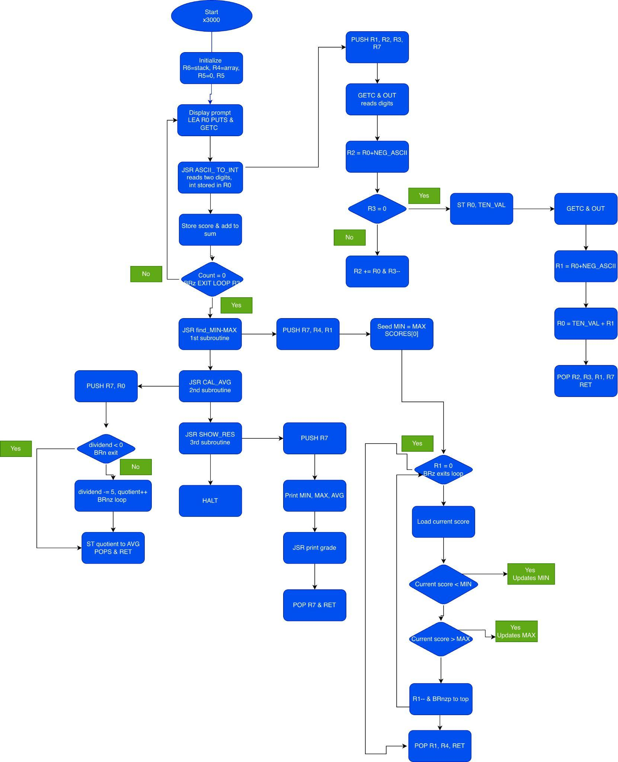
Include branching, iteration, subroutines/functions in flow chart or pseudocode.

